

**Department of Electrical Engineering**

**Optional 1: 2-bit Multiplier**

Name: Socheath Sok, ID: 014470701

Professor: Dr. Ray Wang

Class: EE 301

Date Due: December 11, 2017

**Explanation**

The goal of this lab is to design a 2-bit multiplier. This can be accomplished in multiple ways which includes describing the design behavior based on the truth table, making a design with full adders as the component or creating the design using half adders. From the options given, the half-adder design seem to be the most simple and shortest one because there is no complicated connection and less inputs and signals are required since there is no ‘carry in’ input for the half adders. In addition to the adders, four AND gates were also required to combine inputs ‘a’ and ‘b’, which are connected to the switches, before they can be connected to the adders. Lastly, the structural code for the 2-bit multiplier with four input, four output and one wire signal to connect the two half adders was created, tested and implemented on the board.

**VHDL Code for Half Adder**

library IEEE;

use IEEE.STD_LOGIC_1164.ALL;

entity Half_Adder is

Port ( A : in STD_LOGIC;

B : in STD_LOGIC;

S : out STD_LOGIC;

C : out STD_LOGIC);

end Half_Adder;

architecture Behavioral of Half_Adder is

begin

S <= A xor B;

C <= A and B;

end Behavioral;

**Structural Code**

library IEEE;

use IEEE.STD_LOGIC_1164.ALL;

entity Multiplier is

Port ( a : in STD_LOGIC_VECTOR (1 downto 0);

b : in STD_LOGIC_VECTOR (1 downto 0);

c : out STD_LOGIC_VECTOR (3 downto 0));

end Multiplier;

architecture Behavioral of Multiplier is

component Half_Adder

Port( A : in STD_LOGIC;

B : in STD_LOGIC;

S : out STD_LOGIC;

C : out STD_LOGIC);

end component;

signal x : std_logic_vector(3 downto 0);

signal carry : std_logic;

begin

x(0) <= a(0) and b(0);

x(1) <= a(0) and b(1);

x(2) <= a(1) and b(0);

x(3) <= a(1) and b(1);

c(0) <= x(0);

Q1: Half_Adder Port Map(x(1), x(2), c(1), carry);

Q2: Half_Adder Port Map(carry, x(3), c(2), c(3));

end Behavioral;

**TestBench**

library IEEE;

use IEEE.STD_LOGIC_1164.ALL;

use IEEE.STD_LOGIC_unsigned.ALL;

ENTITY Multiplier_test IS

END Multiplier_test;

ARCHITECTURE behavior OF Multiplier_test IS

COMPONENT Multiplier

Port ( a : in STD_LOGIC_VECTOR (1 downto 0);

b : in STD_LOGIC_VECTOR (1 downto 0);

c : out STD_LOGIC_VECTOR (3 downto 0));

END COMPONENT;

signal test_seq : std_logic_vector( 3 downto 0);

signal a : std_logic_vector(1 downto 0) := (others => '0');

signal b : std_logic_vector(1 downto 0) := (others => '0');

signal c : std_logic_vector(3 downto 0);

BEGIN

uut: Multiplier PORT MAP (

a => test_seq(3 downto 2),

b => test_seq(1 downto 0),

c => c );

stim_proc: process

BEGIN

test_seq <= "0000";

wait for 10 ns;

for i in 0 to 15 loop

test_seq <= test_seq + "0001";

wait for 10 ns;

end loop;

wait;

end process;

END;

**WaveForm**

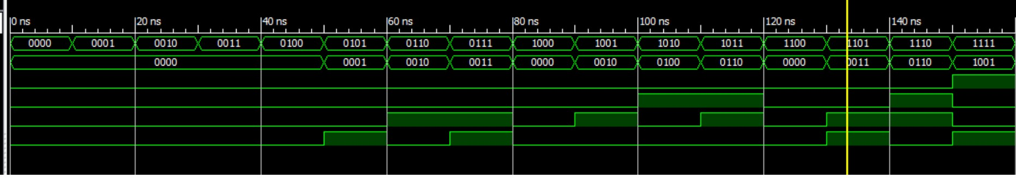

**Constraint File**

Net "a(0)" LOC = "P11";

Net "a(1)" LOC = "L3";

Net "b(0)" LOC = "K3";

Net "b(1)" LOC = "B4";

Net "c(0)" LOC = "M5";

Net "c(1)" LOC = "M11";

Net "c(2)" LOC = "P7";

Net "c(3)" LOC = "P6";